Probability
Grades 2-3
Leighann Mensen, Central Elementary, leighann_mensen@isd31.net
Kara Foehrenbacher, Northern Elementary, kara_foehrenbacher@isd31.net
Angie Bonik, Northern Elementary, angela_bonik@isd31.net

Executive Summary
This unit is designed to build probability concepts. Through games and activities students will practice different strategies to solve probability problems involving how likely or unlikely certain events are. These units align with the Minnesota K-12 Academic Standards under Data Analysis in third grade and the NCTM Standards under Data Analysis and Probability in grades Pre-K-2 and 3-5.

MN State Standards

3.4.1.1 Collect, display and interpret data using frequency tables, bar graphs, picture graphs and number line plots having a variety of scales. Use appropriate titles, labels and units.

NCTM Standards
Pre-K–2 Expectations: In pre-K through grade 2 each and every student should–
- discuss events related to students' experiences as likely or unlikely.
Grades 3–5 Expectations: In grades 3–5 each and every student should–
- propose and justify conclusions and predictions that are based on data and design studies to further investigate the conclusions or predictions.
Grades 3–5 Expectations: In grades 3–5 each and every student should–
- describe events as likely or unlikely and discuss the degree of likelihood using such words as certain, equally likely, and impossible;
- predict the probability of outcomes of simple experiments and test the predictions;
- understand that the measure of the likelihood of an event can be represented by a number from 0 to 1.

MCA Test Sample Question
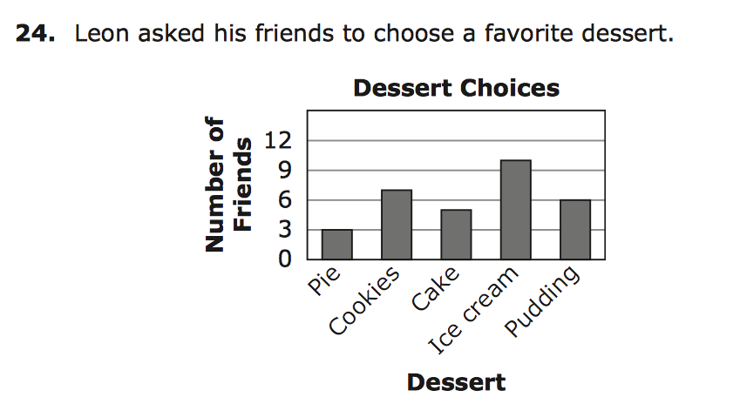
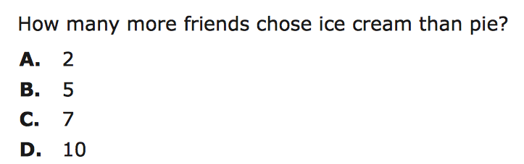

Table Of Contents

- Can You Make It Into The Trash Can?
- Lucky Coin
- Roll and Tally
- Some Sums
- It’s in the Bag
- Bottle Flipping
- S.K.U.N.K
- Likely or Unlikely
- Probability Continuum
- Blue wins!
- Skittle Math
- Probability Jars
- Is Rock, Paper, Scissors Fair?
- Baseball Statistics Game
- Baseball Statistics Game Cont’d

Pre/Post Test Name:__________________

1. There are four coins in my pocket. Three are quarters and one is a nickel. Describe the probability of picking a dime.

- certain
- likely
- unlikely
- impossible

2. You flip a coin and it lands on tails. When you flip it again it will most likely be:

- tails again
- heads
- an equally likely chance of getting heads or tails
- neither heads or tails

3. There are 16 marbles in a box. 10 are blue, 2 are yellow, and 4 are red. Describe the probability of drawing a yellow marble.

- certain
- unlikely
- impossible
- likely

4. A baseball player has an average of 714/8,399 home runs, 136/8,399 triples, 506/8,399 doubles, and 1,356/8,399 singles in his career. Which event was least likely for this baseball player?

- home runs
- triples
- doubles
- singles

5. I have two dice and I roll them both at the same time. Describe the probability of getting two ones.

- likely
- unlikely
- impossible
- Certain

Likely or Unlikely?

MN State Standard | Materials
Develop and evaluate inferences and predictions that are based on data  Pre-K–2 Expectations: In pre-K through grade 2 each and every student should–  - discuss events related to students' experiences as likely or unlikely. | *set of statement cards for each group  *Chart paper or other tool to save discussion points and create an anchor chart
Objective: The students will sort event cards into groups of LIKELY or UNLIKELY based on their conversations in groups of 3-4.

Launch: What do you know about the word LIKELY? How about if I said UNLIKELY? Today we are going to talk about these two words and see if we can come to an agreement about what the mean and how we can use them in math.

Explore: In groups students should read the statements on the cards and sort them into 2 groups based on whether they think the statement is likely to happen or unlikely to happen.

Share: Students from each group should share what they talked about during their discussion. Write facts they share on the board to create a list.

Summarize: After students share what their groups talked about and how the statement cards were sorted write a definition as a class for the terms LIKELY and UNLIKELY on an anchor chart.

Statement cards:
We will have lunch at school today. | The busses will take kids home today.
A space alien will visit our class tomorrow. | We will go on a field trip this year.
We will be able to see the stars in the sky at recess. | We will have school on Saturday.

Probability Continuum
MN State Standard | Materials
Develop and evaluate inferences and predictions that are based on data  Pre-K–2 Expectations: In pre-K through grade 2 each and every student should–  - discuss events related to students' experiences as likely or unlikely. | *Chart paper or other tool to save discussion points and create an anchor chart  *Word Chart for each student group
Objective: The students will explore the vocabulary of impossible, unlikely, equal chance, likely, certain

Launch: We are going to explore some new words today. What do you think when I say the word impossible? How about certain? What does the word equally mean? In groups today you are going to discuss these words along with a few more and put them in order.

Explore: Hand out the work chart to each student. Working in groups they should cut out their words and place them in an order after discussing with their groups.

Share: Students from each group should share what they talked about during their discussion. As a class discuss each word and see if you can put them in an order that would make sense and record them on chart paper. Then add the number line to the ordered words on the chart

Summarize: How does this help us to know these words? We will be using these words in our math talks now that we know what they mean and how to use them!

Source:https://www.teacherspayteachers.com/Product/Probability-Activities-and-Vocab ulary-Practice-with-Dice-Coins-and-Spinners-317293

EQUALLY LIKELY
CERTAIN
IMPOSSIBLE
LIKELY
UNLIKELY

Which Spinner--Blue WINS!
MN State Standard | Materials
Grades 3–5 Expectations: In grades 3–5 each and every student should–  - propose and justify conclusions and predictions that are based on data and design studies to further investigate the conclusions or predictions. | *set of spinners cards for each group  *crayons  *paperclips  *Chart paper or other tool to save discussion points and create an anchor chart
Objective: The students will decide which spinner they would choose to use in order to get the desired color.

Launch: Today we will be trying to see if we can figure out how to be most likely to win a game with spinners! Who likes to be a winner when they play a game? What if you could use MATH to have a better chance to beat the other players? Let’s get our spinners ready. *Direct the students to color the spinners using a blue crayon and any other colors they want to. Color only 1 section on each spinner with each color.

Explore: Students will look at each spinner and predict which would give them the best chance of winning the game. Then groups will spin each spinner 25 times and collect the data on the chart.

Share: As a whole class record the data collected on an anchor chart and see if you can draw some conclusions based on the data.

Explore more: :) In groups again have students test your conclusions by drawing a spinner of their own that would give them a high probability of winning the most spins. Then they will test their spinners and record their data.

Summarize: What can you tell about the probability of getting the color you want when you spin the spinners? Explain to us why you designed your spinner the way you did.

BLUE WINS!!!

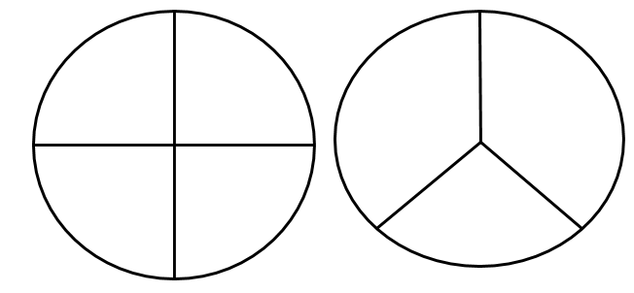
Spinner 1 Spinner 2
How many blue spins? How many blue spins?
_____________________________ ____________________________

Your own spinner!!!

How many blues? _____________

Lucky Coin

Standard:
“Predict the probability of outcomes of simple experiments and test the predictions;” NCTM 2000, p. 176

Objective:
Students will determine that with a fair coin heads or tails are equally likely to occur and that size and weight do not affect toss outcomes.
Students will predict how often an event will occur in a given number of trials.

Materials:
-Real Coins: one penny, one nickel, one dime (for each pair of students)
-Piece of paper (for recording trials)
-Pencil

Launch:
Ask students “Have you ever heard of a lucky coin?” Students will most likely answer yes and have a few of them share where they have seen or heard or a lucky coin. Ask students if they think there is such a thing as a lucky coin and if they know what happens when you flip a coin. Discuss that the two outcomes are heads and tails. Ask students if it matters if you flip a penny or a nickel what the outcome will be. Ask students “How can we test this?” Guide them to conducting trials of flipping different coins to see what outcomes we can get.

Explore:
Divide students into pairs and give them one penny, one nickel, and one dime. Explain that students will be flipping coins to see if heads or tails show up more often. Have students flip and record a total of 10 times for each coin (students determine how they will divide the work of flipping coins and recording). Have a chart on the board with a place for each coin name, the number of heads, and the number of tails. As pairs finish recording their results have them record them on the class chart on the board as well.
Ex.
 | Penny  H T | Nickel  H T | Dime  H T
Group 1 | 4 6 | 7 3 | 5 5
Group 2 | 6 4 | 2 8 | 9 1

Share:
Have students present their findings and if they noticed any differences in the tosses for each coin. As groups share make sure to ask questions about which coin had the most heads or tails and why they think that is. Ask “Does this experiment show that one coin is more lucky than another?” “Why do you think that?”

Summarize:
Make sure students understand that by looking at the class data and discussing the results they realize that tossing a heads or tails, no matter which coin you use, is equally likely.

Assess/Analyze:
Have students answer “Explain why each coin has an equally likely chance of landing heads up or tails up.” on an exit slip.

Source: Navigating Through Data Analysis and Probability in Grade 3-5

Roll and Tally
Launch
In today’s lesson, we will begin by asking students “What number on a number cube occurs the most when rolling”. We will determine which number on the number cube occurs the most and least by rolling and collecting data. Students will make a prediction of what number will occur the most and least. We will then compile everyone’s data on a large graph and discuss which number occurred the most and least within our class and discuss why. Today’s lesson will cover MN Standards 2.1.1.1, 2.1.2.6, 3.4.1.1, and 3.1.3.1.
Explore
Individually, students will roll a number cube twenty-five times. After each roll, students will record which number they rolled (1, 2, 3, 4, 5, or 6) using tally marks or pictures of number cubes. After twenty-five rolls, students will determine: Which number turned up the most often? Were there any that occurred the same number of times? Which number turned up the least? Students will then roll their number cube twenty-five more times and record their data. They will then collect the same data from their first roll to see if it is the same or different.

Recording Sheet Example
 |  |  |  |  | 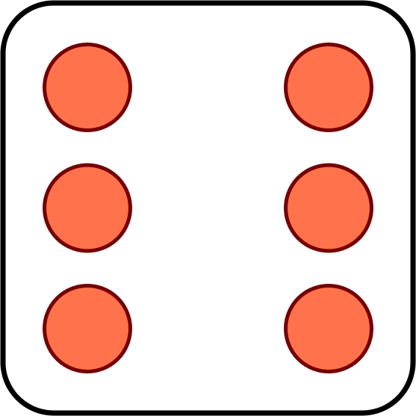
 | 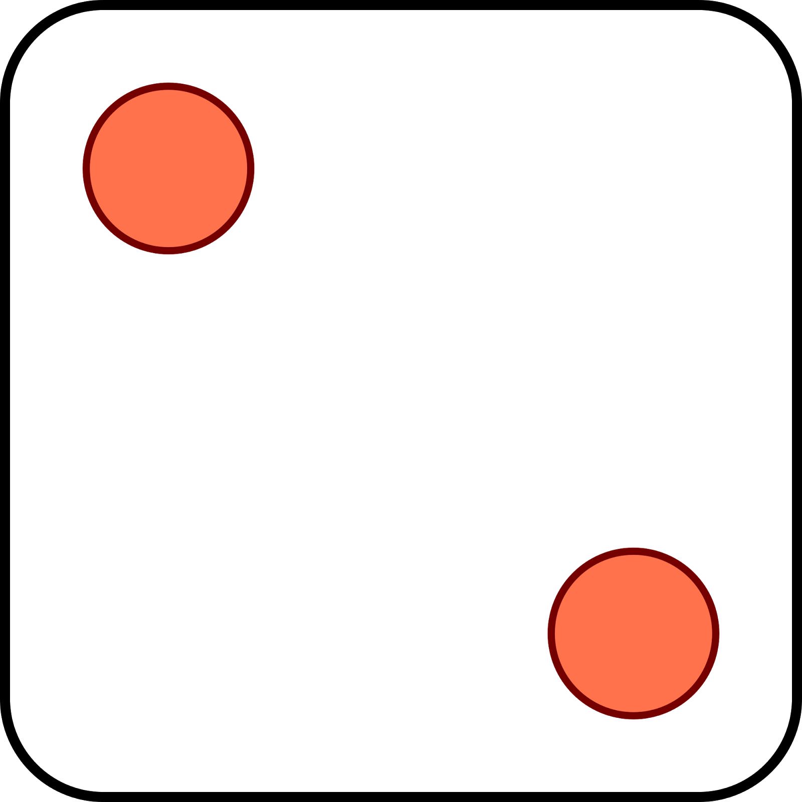
 |  |  |  | 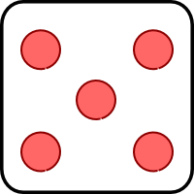
1 | 2 | 3 | 4 | 5 | 6

Share
Students will share their results from their first and second round of rolling. Data will be collected on a large tally chart for the class to examine together. Did anyone’s data or predictions match the class’s data? What do you think would happen if we rolled twenty-five more times?
Summarize
The main idea of this lesson was to examine probability of events that are equally likely to happen and to make ways to display data collected.

Some Sums
Launch
Ask students, “What total are you most likely to roll using two number cubes?” Have students make a prediction and write it down. Using prior knowledge of adding and multiplying single-digit numbers, recording numerals through 20, and identifying odd and even numbers, we will conduct experiments using number cubes. We will identify the sums and products that are most and least likely to occur and those that have the same chance of occurring. We will be addressing MN Standards: 2.1.2.2, 2.1.2.6, and 3.4.1.1.
Explore
Whole Group
We will review even and odd numbers together (even being numbers we say when counting by twos, odd being the other numbers). We will also review the numbers found on the six faces of each cube.
Small Group
Working in pairs, students will roll the cubes twenty times, recording their sum or product of the number cubes (2nd graders will compute the sum, 3rd graders will compute the product) as addition or multiplication sentences. After twenty rolls, each pair will identify their odd and even sums/products. Students will then record their data on frequency table to show the number of times a sum or product was rolled. Have pairs identify the sum/product that occurred the most and least often.

Roll | Cube Sum/ Cube Product
1 | ex.) 2 + 3 = 5
2
3
4

Sum / Product | Number of Times Rolles
2
3
etc...

Share
Students will share the sum/product that occurred the most and least. As a class, we will discuss if it is possible to get a 1 as a sum or product. If not, why? If so, how? We will also discuss the smallest possible sum or product and greatest possible sum or product. We will also share what students had to roll to get a sum/product of 2, 3, 4, 5, 6, etc…
Results of each group will be recorded onto a class frequency table for all to see. If we rolled the cubes again, which sum or product would you most likely to get? Which one would you least likely to get?
Summarize
The main idea of this lesson was to have students be able to identify odd and even numbers, add or multiply with fluency, and through exploration, identify likely and unlikely events with the use of number cubes.

S.K.U.N.K.
Launch
Begin by asking students if some people are just lucky or if they are smart in the choices they make. Today we will be playing a number cube game called S.K.U.N.K. where students will have to determine when to stop playing in order to win. Students will have prior knowledge on the probability of rolling number cubes and the outcomes that can happen when you roll two number cubes. This game will be played using addition for 2nd graders and multiplication for 3rd graders. MN Standards addressed are 2.1.2.6.
Explore:
Whole Group
Begin by reviewing the possible combinations for sums or products when rolling two number cubes. Also examine the probability of rolling a 1 on any of the number cubes. This game will be played as a whole group. The teacher will roll two number cubes and the students will fund the sum or product for that roll. After the sum or product is determined, students record that total under the “S” column. At this time, students have the option of sitting down or keep standing up. If students sit down, they are done playing for that round and keep their points. If students decide to keep standing, the play continues and will record the sum or product for each roll. The play will end for that round if a 1 is rolled. Anyone still standing when this happens will lose all of their points for that round. The activity will continue for each remaining round (K, U, N, K) following these directions. At the end, each student will total up their points they got to keep and the student with the most points will be the winner
.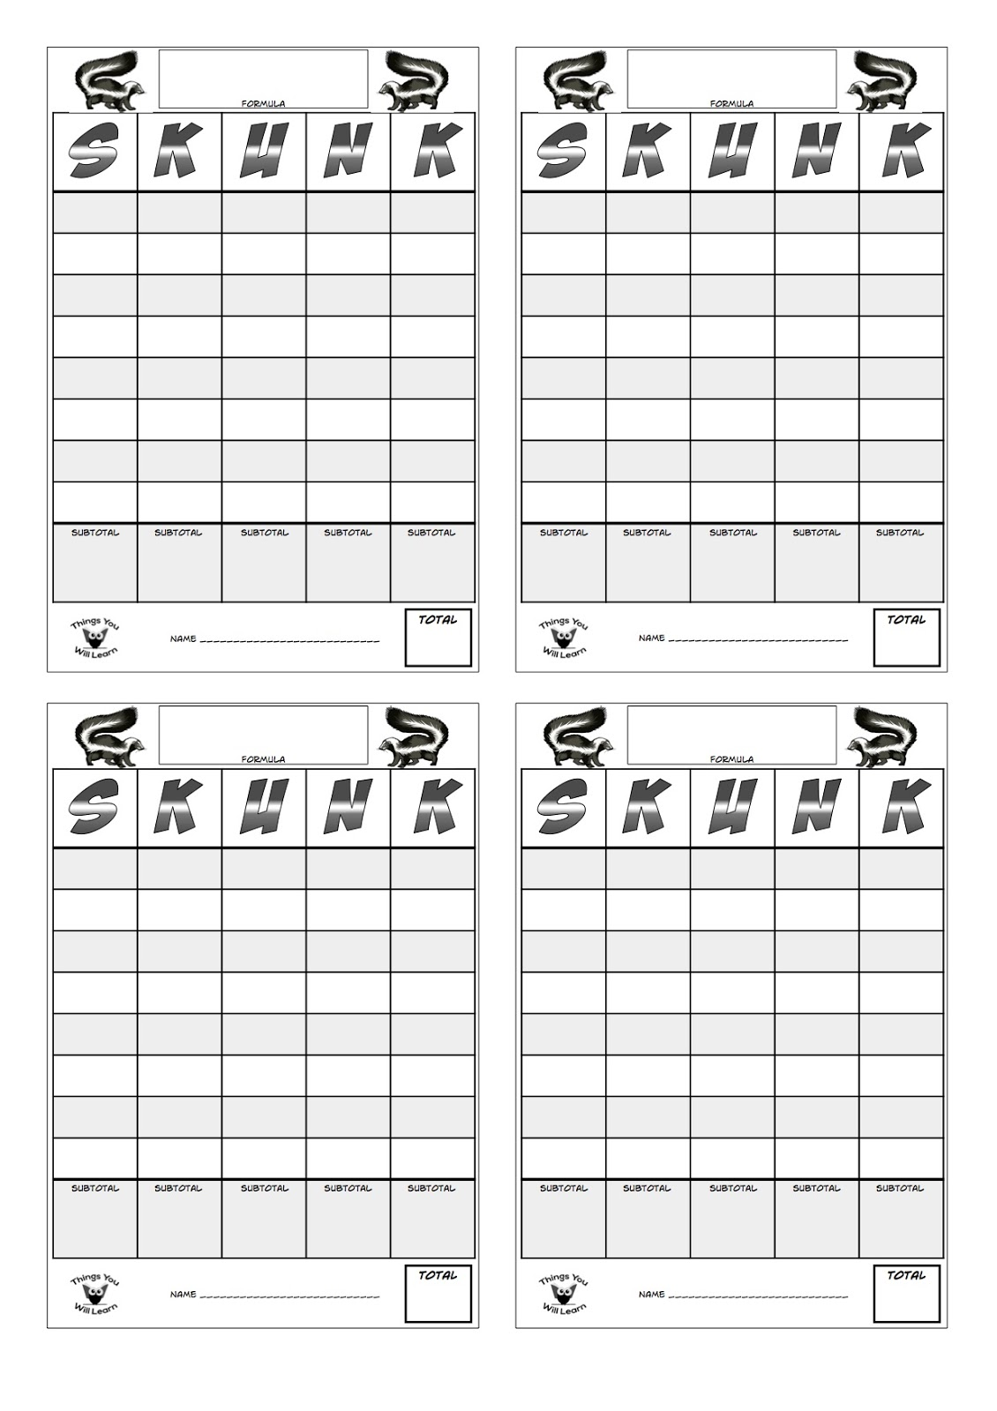
Summarize:
The main idea of this activity is for students to use what they know about probability using two number cubes to help them determine when to stop playing and keep their points.

Things You Will Learn (n.d.). The Game of Skunk Scorecard. Retrieved June 26, 2017 from www.teacherspayteachers.com

Bottle Flipping
Launch
“How many of you have ever tried to flip a water bottle?” “How many tries did it take you to successfully flip the bottle?” Most students have tried this in school so today, students will be using three water bottles filled with different amounts to flip on their desks. Students will make a prediction and record which bottle they will be able to flip and land on its end the most to the one they think will land on its end the least. Students will then conduct trials and record their data. This activity covers the MN Standards 2.1.2.2 and 3.4.1.1.
Explore
Working in groups of three, each group will be given three water bottles filled with different amounts. One bottle will be filled 1/4 of the way, the second bottle will be filled half way, and the last bottle will be filled ¾ of the way. Each student will flip their water bottles 25 times, recording their results after each flip (landing on its end or side) using a tally chart. They will continue this experiment with the other two water bottles recording results as they go.
Share
Students will individually look at their results and total the number of times they landed the water bottle on its end for each of the three filled water bottles. They will then share their results with their group and determine if there are any similarities or differences. They will then share if their predictions were correct or not. Results will be shared with the class to determine if there are any factors that contributed to the results and if the results were similar for everyone.
Bottle Flipping Challenge
Bottle | End | Side | Total out of 25
#1 (¼ full) |  |  | /25
#2 (½ full) |  |  | /25
#3 (¾ full) |  |  | /25

Summarize
The main idea of this lesson was to have students conduct an experiment of probability, collect data, and examine the data collected to determine the chances of success for bottle flipping as impossible, uncertain, or certain.

Skittle MATH
MN State Standard | Materials
Grades 3–5 Expectations: In grades 3–5 each and every student should–  - propose and justify conclusions and predictions that are based on data and design studies to further investigate the conclusions or predictions.  - predict the probability of outcomes of simple experiments and test the predictions; | *snack size bag of Skittles for each student  *Chart paper and markers  *Math journal or recording paper for students
Objective: The students will explore the relationship between the fraction of each color to the group of Skittles.

Launch: Do you pick through the bag to get your favorite color and leave the others? Do you think we can use math to predict which color is most or least likely for us to get? Let’s explore!!

Explore: Students take all of the skittles out of their bag. They count the total number of skittles. Then sort them into color piles and record the total for each color. As a group discuss how you could show the part of each color in the whole. They should come up with a fraction as the method to record. Can we use our fractions to predict which color would be chosen most if we were to not look and just pick?
**Experiment!! Mix up your Skittles and close your eyes. Pick one Skittle and make a tally chart to record the color you pick. Do this 25 times.

Share: As a whole class record the data collected on an anchor chart and see if you can draw some conclusions based on the data.
Summarize: What can you tell about the probability of getting the color you want when you look at the fractions we have?

Can You Make It Into The Trash Can?
Standard:
“Understand and apply basic concepts of probability” and “describe events as likely or unlikely and discuss the degree of likelihood using such words as certain, equally likely, and impossible;” NCTM 2000, p. 176

Objective:
Students will describe an event as certain, likely, equally likely to occur and not occur, unlikely, or impossible.
Students will quantify the likelihood of an event using a value from 0 to 1.

Materials:
-Sheets of paper
-Trash cans
-Tape measures
-Masking tape
-Sticky notes
-Recording sheets
-Pencils

Launch:
Students have some prior experience with collecting data, representing data on a graph, and using a measuring tape from previous lessons. Start writing today’s goal on the board (with a dried out marker) and when it doesn’t work carefully toss it into the trash can. Whether you make it into the trash or not there is sure to be a reaction from the students. Ask students if they have ever tried to toss something into the trash can and if they usually make it or miss. Pose the question “can we predict whether or not something will go in the trash can?” Use a marker (that does work) to write the words “certain”, “likely”, “equally likely”, “uncertain”, and “impossible” on the board. Discuss what each of these mean and have students come up with examples of events for each outcome. Ask students if they have any suggestions for an experiment they could conduct to find an answer for predicting if an item tossed towards a trash can will make it or not. Guide students toward throwing a paper ball into a trash can and recording the data for all students in the class.

Explore:
Divide students into groups of three. Give students a trash can, measuring tape, masking tape, pieces of paper, and a recording sheet. Explain that each student will be making tosses from 10 cm, 100 cm, 300 cm, and 6m. Tell the class that the 6m toss will be made with their eyes shut! Students should start by measuring and marking distances from their trash can using the measuring tape and masking tape. As students do this go around and make sure students are measuring and marking correctly. Once students have their distances marked they will make predictions for how many of their tosses will make it into the trash can for each distance. They may start tossing the paper ball three times from each distance after they have made their predictions. Remind students of the importance to record whether the ball goes in or not at each distance and for each throw. As students are conducting their experiment walk around and make sure students are making predictions before tossing, recording correctly, and taking turns.

Share:
Have students share the data they collected with the class and record it on a class record sheet. Ask each group to present their findings and what they think these results mean. Discuss which distances had the most that went in and which had the least. Point to the previously written words on the board and ask what connections they can make from those words to the data they collected.

Summarize:
Explain that the tosses made from 10 cm were certain to go in and the tosses made from 6 m with their eyes closed were impossible to go in. Explain that the other distances were maybe likely, or unlikely depending on the results. This experiment shows that we can to some degree predict whether the paper ball will go in or miss the trash can depending on the distance from the can and whether or not you get to keep your eyes open.

Assess/Analyze:
Have students write an event that is certain, likely, equally likely, unlikely, and impossible on a piece of paper. Make sure students label each event with the correct word.

Source: Navigating Through Data Analysis and Probability in Grade 3-5

Name:_____________________

Trash Can Tosses Record Sheet

Distance | Number of Tosses That Went In | Total Number of Tosses | Tosses In/ Total Tosses | Description (certain-  impossible)
10 cm
100 cm
300 cm
6 m (eyes closed)
Example: | 3 | 3 | 3/3 | certain

Name:_____________________

Trash Can Tosses Record Sheet

Distance | Number of Tosses That Went In | Total Number of Tosses | Tosses In/ Total Tosses | Description (certain-  impossible)
10 cm
100 cm
300 cm
6 m (eyes closed)
Example: | 3 | 3 | 3/3 | certain

Is Rock, Paper, Scissors Fair?

Standard:
“Understand and apply basic concepts of probability” and “describe events as likely or unlikely and discuss the degree of likelihood using such words as certain, equally likely, and impossible;” NCTM 2000, p. 176

Objective:
Students will describe an event as certain, likely, equally likely to occur and not occur, unlikely, or impossible.

Materials:
-paper
-pencils

Launch:
Ask for a volunteer to come up to the front of the room. Tell them that you want to play rock, paper, scissors against them. Best two out of three wins. Play the game with the student. No matter who wins ask the class if they think it was a fair game. Why is it or isn’t it fair? Explain that students will be determining if the game rock, paper, scissors is a fair game by playing against each other and recording their results.

Explore:
Let students choose a partner to play against and tell them to play 20 rounds and record the results of each game. Give students time to record their trials and ask students to come and record their results on a class record sheet on the board.

Share:
When students have finished their trials and have recorded their data on the class record sheet on the board have pairs of students share whether they think the game is fair. Have the pairs defend their answer of fair or unfair. Discuss as a class what the probability is of winning a round of rock, paper, scissors. Write the choices that each person has on the board and have students decide what the probability is for each choice. They should be able to say that each person has a ⅓ chance of choosing either rock, paper, or scissors. What are all of the combinations you could have?

Player 1 | Player 2
R | P
R | S
R | R
P | R
P | S
P | P
S | R
S | P
S | S

What are the combinations that win? Player 1 wins 3/9 times and Player 2 wins 3/9 times. Then ask the question is it certain, likely, equally likely, unlikely, or impossible that you will win?

Summarize:
There is an equal chance of each player winning each round. There are ways to make the game less fair if you notice patterns in the choices your opponent makes or if you aren’t making your choice exactly at the same time. Tell students that you will be playing more rock, paper, scissors in the future and they can continue to think about whether the game is actually fair.

Assess/Analyze:
Give students the question of whether rolling an even number on a die with numbers 1-6 is certain, likely, equally likely, unlikely, or impossible. Have them write their answer on an exit slip.

It’s In the Bag
Launch
Today’s lesson will look at chance and examine what is considered “fair”. We will also look at certain and impossible events that can occur using colored cubes and a bag. Show the students a bag that contains one red, one green, and two blue cubes. Ask how many cubes there are. Ask how many different colors there are. Put the cubes in a bag before you continue.
Explore:
Whole Group
With the cubes in the bag, ask students what color they think I’ll pull out the most? Why? Does each color have an equally likely chance of being pulled from the bag? Why or why not?
Small Group
In groups of four, hand out paper bags each with one red, one green and two blue cubes for each group. Have each group shake the bag and pull out a cube, recording the color before returning it to the bag, shaking it, and drawing another cube out. After twenty trials, have each group total their results and have them answer the following questions: Which color was selected the most? Least? Did you expect this result? What the number of blue cubes selected close to ten? Would it be possible to pull a red cube from the bag? Why? Is it possible to pull a yellow cube from the bag? Why? If you did 100 trials, how many times would you expect to pull the blue cube from the bag? MN Standards covered in this activity are 2.1.1.1, 2.1.2.2, 2.1.2.6, and 3.4.1.1.
It’s In the Bag
Red
Green
Blue

Share
After all twenty trials are done in each group and they have answered the questions at the bottom of the sheet, discuss the results of each group. Did any group pull more red or green than blue? Are each group’s results similar? Why?
Summarize
The main idea of this lesson is for students to determine the probability of an event occurring before conducting an experiment. Students also use and further define impossible, certain, and fair.

Probability Jars
MN State Standard | Materials
Grades 3–5 Expectations: In grades 3–5 each and every student should–  - propose and justify conclusions and predictions that are based on data and design studies to further investigate the conclusions or predictions. | *Jars- plastic jar for each group, should be see through  *colored cubes  *Task cards  *Math Journals or recording paper for students
Objective:.The students will create and identify Probability jars based on the task card their group has and their knowledge of probability.

Launch: Today you are going to show us all how much you know about probability by creating your own Probability jar and the class will try to chose which jar your group created! It will be a big puzzle for us all to figure out!

Explore: Each group will take their task card, a bucket of color cubes and a task card to their work space. As a group they should read the clues and create a jar by placing cubes in the jar that would support the clues on the card. Groups should then place their jar on the front table for others to look at, but keep their card.

Share: As a class gather together and each group takes turns reading their task card to see if the class can choose which jar would be theirs. Then the group will explain why they put the numbers of cubes in the jar.

Summarize: Today we showed how much we know about the chance of getting each color based on how many cubes are possible and the probability of each color.

RED is impossible  BLUE is likely  GREEN is unlikely  YELLOW is unlikely | RED is likely  BLUE is unlikely  GREEN is impossible  YELLOW is unlikely
RED is equally likely  BLUE is equally likely  GREEN is equally likely  YELLOW is impossible | RED is equally likely  BLUE is equally likely  GREEN is equally likely  YELLOW is equally likely
RED is likely  BLUE is impossible  GREEN is likely  YELLOW is unlikely | RED is likely  BLUE is unlikely  GREEN is unlikely  YELLOW is likely
RED is equally likely  BLUE is equally likely  GREEN is equally likely  YELLOW is impossible | RED is unlikely  BLUE is likely  GREEN is unlikely  YELLOW is likely

Baseball Statistics Game

Standard:
“Understand and apply basic concepts of probability” and “describe events as likely or unlikely and discuss the degree of likelihood using such words as certain, equally likely, and impossible;” NCTM 2000, p. 176
3.4.1.1 Collect, display and interpret data using frequency tables, bar graphs, picture graphs and number line plots having a variety of scales. Use appropriate titles, labels and units.

Objective:
Students will describe an event as certain, likely, equally likely to occur and not occur, unlikely, or impossible.
Students will collect and interpret data using Google to find baseball stats for players.

Materials:
-Chromebooks (or computers in the tech lab)
-Baseball stats example chart
-Baseball stats game handout
-pencils

Launch:
How many students like sports? How many of you like baseball? Do you know any player’s names? Put an example of baseball stats on the board and ask students if anyone has seen these before. Explain that they are the statistics of that player over certain years or their entire career. Each one tells us something different. There are numbers that tell us how many times the player was at bat, hit a homerun, hit a triple, hit a double, etc. Today you will have a chance to look up some baseball statistics of a player of your choice (have a list of player names for those that cannot think of one on their own). You will use a Chromebook to search Google for your players stats and record them on the handout. You will need to record them as the stat number over the total times at bat. Show an example on the board so students know how to record their stats.

Explore:
Give students the Chromebooks and have them start searching for the stats for their player. Go around the room while they search to make sure students are finding the right information and are recording it correctly. After students have been searching and recording awhile stop them and explain that they will be using these stats to play a game tomorrow so they need to make sure to finish recording their player’s stats today. Have students start filling out the game board squares when they finish recording their stats. Show an example on the board.

Share:
Allow students time to share with each other what the stats they found were and which players they chose. Ask students to compare their stats with others and see if they can figure out which players are maybe better than others.

Summarize:
Explain to the class that the game they will be playing tomorrow will require them to be in teams and so they will need to choose teams of four for class tomorrow. They can think about and discuss what teams they want to be on before class starts tomorrow.

Assess/Analyze:
Give students this exit slip:

Babe Ruth had an AB of 8,399 and his HR total was 714. What do AB and HR stand for when reading baseball statistics. Is it certain, likely, unlikely, or impossible for Babe Ruth to get a HR if he were to go up to bat again?

Source: Mathematics Teaching In The Middle School

Baseball Statistics Game Cont’d

Standard:
“Understand and apply basic concepts of probability” and “describe events as likely or unlikely and discuss the degree of likelihood using such words as certain, equally likely, and impossible;” NCTM 2000, p. 176

Objective:
Students will describe an event as certain, likely, equally likely to occur and not occur, unlikely, or impossible.

Materials:
-Baseball statistics game-card worksheet
-pencils
-large paper clips (for spinners)
-Baseball playing diamond sheet
-pennies (for players to move around the diamond)

Launch:
Yesterday we collected data on baseball players and recorded the statistics we found on our worksheet. Today we will be using that information to play a game of baseball against another team in the class. Students should have chosen teams of four. If students didn’t have a chance to fill out the game board yesterday, give them a few minutes to finish. Explain that they will be using a large paper clip and a pencil to make two spinners on their worksheet. Demonstrate how to do this. Students will spin the top spinner for the vertical axis and the bottom spinner for the horizontal axis. These are the coordinates they should use to find if they get to move one base, two bases, etc.

Explore:
Each team plays until they have three outs and then it is the next team’s turn. Have students keep track of where they are on the diamond with pennies and record the number of outs and runs on a piece of paper. Have teams play 5 innings and then switch and play 5 innings with another team.

Share:
Have students share their experiences with playing this game. Did they notice anything that made events more or less likely to occur? How did their game boards differ from each other and how did that affect the game? Ask the winning teams if they had any ideas as to why they won. Discuss whether or not this is a fair game. Why or why not?

Summarize:
Today we used data we collected to create a game board that we used to play a game of baseball against another team. Students who chose players with high averages of home runs, triples, doubles, and so on had a higher chance of earning their team runs. Also, the students who spread their filled squares around the board had a greater chance of getting on base then getting an out.

Assess/Analyze:
Have students write their own question that they would give to a friend about their player’s baseball statistics.

Source: Mathematics Teaching In The Middle School

